**Waste Table 2–Improving reuse and recycling of servers and components for all cloud hardware**

In FY23 Microsoft increased reuse and recycling of servers and components to 89.4%

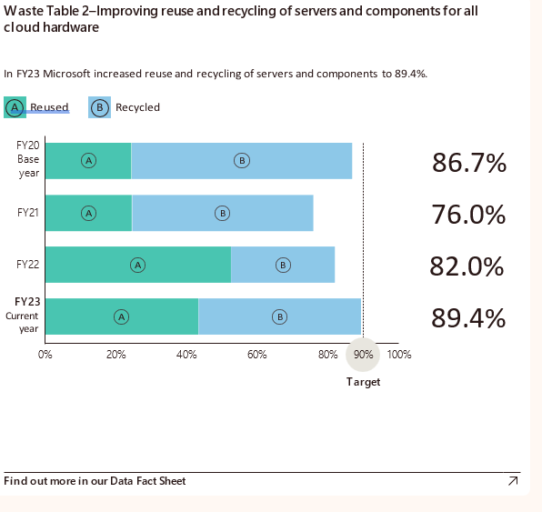

Horizontal stacked bar graph showing the percentage of improvement in the reuse and recycling of servers and components for all cloud hardware from fiscal years FY20 to FY23. The data shows a gradual decrease in reuse and recycling rates, starting at 86.7% in FY20, decreasing to 76.0% in FY21, then increasing to 82.0% in FY22, and peaking at 89.4% in FY23. The majority of servers and components were recycled in FY20 and FY21, followed by reuse. Conversely, in FY22 and FY23, most servers and components were reused, followed by recycling. FY20 is designated as the base year, and FY23 as the current year, with a target of 90% indicated.